BUSINESS INTELLIGENCE LAB
UNIT 3 | SESSION 8
EXPERIMENT 8
Report Scheduling, Automation and Alerts using Microsoft Power BI

1. AIM
To design and implement report scheduling, automation, and alert mechanisms using Microsoft Power BI and develop strategies for automated report delivery, monitoring, and business performance tracking.
2. OBJECTIVES
- To reuse the existing Power BI report, Executive Dashboard, and Business Scorecard developed in the previous experiments.
- To create a scheduling plan for Daily Sales Reports, Weekly Profit Reports, and Monthly Executive Dashboards.
- To design a Report Distribution Matrix covering user groups, reports, frequency, and delivery methods.
- To configure email subscriptions in Power BI Service for automated report delivery at 6:00 AM.
- To define and configure KPI alerts for Profit Margin, Sales decline, and Returns increase.
- To analyze a monitoring scenario where a regional branch shows declining profitability, and recommend corrective actions.
3. TOOLS / SOFTWARE REQUIRED
- Microsoft Power BI Desktop.
- Microsoft Power BI Service (app.powerbi.com, Power BI Pro trial).
- Existing Power BI project file from the previous experiments, published as BI Expe-8.
- Global Superstore Dataset.xlsx.
- DAX (Data Analysis Expressions) for KPI and alert measures.
- Microsoft Outlook (university email) to receive subscription emails.
- Microsoft Excel.
4. DATASET USED
Dataset: Global Superstore Dataset (Kaggle).
Source: https://www.kaggle.com/datasets/apoorvaappz/global-super-store-dataset
The experiment reuses the same Power BI file and data model built in the previous experiments. The data is used as a fixed (static) snapshot, so no scheduled data refresh was required. The dataset covers sales transactions from 2014 to 2017 across global regions, product categories, and customer segments.
The important fields used in this experiment are:
- Order ID: Identifies individual orders and links orders to returns.
- Order Date / Year: Supports year-on-year comparison for alert measures.
- Sales: Represents sales revenue.
- Profit: Represents profit generated from sales.
- Region: Identifies the regional branch monitored in Part D.
- Category: Identifies product categories (Furniture, Office Supplies, Technology).
- Returns table: Lists returned orders, used for the Returns Change % KPI.
- People table: Lists the regional manager of each region, used to identify alert recipients.
5. THEORY
5.1 Report Scheduling and Automation in Business Intelligence
Business Intelligence systems must deliver information to stakeholders at the right time. Scheduled reporting, automated distribution, and KPI alerts help organizations monitor performance and take timely actions without users having to open reports manually.
5.2 Power BI Service Features Used
Power BI Service supports subscriptions, scheduled refreshes, report sharing, and data-driven alerts:
- Subscriptions: Email a snapshot of a report page, with a link to the report and an optional PDF attachment, on a daily, weekly, or monthly schedule.
- Scheduled Refresh: Reloads the semantic model from its data source at set times so reports and alerts use current data.
- Sharing and Workspaces: Give user groups Viewer access to reports through the workspace or the Share option.
- Data-driven Alerts: Monitor a KPI visual and notify users by email when a value crosses a defined threshold.
- Power Automate: Extends alerts to other recipients and escalation flows.
5.3 Business Scenario
Global Superstore management requires automated delivery of reports and timely notifications whenever business performance changes significantly. In this experiment, the student acts as a BI Operations Engineer and designs the reporting automation strategy.

6. PROCEDURE
Preparation: KPI Measures for Monitoring
Step 1: Opened the existing Power BI project in Power BI Desktop. The report pages available were Geographical Sales Analysis, Relational Report, Matrix Report, Comparative Analysis, Dashboard, Executive Dashboard, Business Scorecard, and Business Insights.
Step 2: Reused the existing measures Total Sales, Total Profit, Total Orders, and Profit Margin %, and created three new measures in the Fact_Sales table for alert monitoring:
Returned Orders =
CALCULATE([Total Orders], TREATAS(VALUES(Returns[Column2]), Fact_Sales[Order ID]))

Sales Change % =
VAR y = MAX(Dim_Date[Year])
VAR prev = CALCULATE([Total Sales], Dim_Date[Year] = y - 1)
RETURN DIVIDE(CALCULATE([Total Sales], Dim_Date[Year] = y) - prev, prev)

Returns Change % =
VAR y = MAX(Dim_Date[Year])
VAR prev = CALCULATE([Returned Orders], Dim_Date[Year] = y - 1)
RETURN DIVIDE(CALCULATE([Returned Orders], Dim_Date[Year] = y) - prev, prev)

Step 3: Added two KPI cards, Sales Change % and Returns Change %, to the Executive Dashboard page next to Total Sales, Total Profit, Total Orders, and Profit Margin %.
Step 4: Saved the file and published it to My workspace in Power BI Service as the report BI Expe-8. Because the data is fixed, no scheduled refresh was configured; the Service shows "Data updated 11/6/26".
Part A: Scheduled Reporting Plan
Step 5: Designed the scheduling plan. All reports are delivered at 6:00 AM (UTC+05:30) so users have them at the start of the working day.
Report | Report Page | Intended Users | Frequency | Time
Daily Sales Report | Dashboard | Sales team, Sales executives | Daily | 6:00 AM
Weekly Profit Report | Comparative Analysis | Regional managers, Finance team | Weekly (Monday) | 6:00 AM
Monthly Executive Dashboard | Executive Dashboard + Business Scorecard | CEO, Directors, Head of Sales | Monthly (1st) | 6:00 AM

Step 6: Opened the report in Power BI Service, selected the Dashboard page, clicked Subscribe, and created the subscription: name Dashboard, recipient added, start date 11/6/2026, Repeat Daily, Scheduled time 6:00 AM.
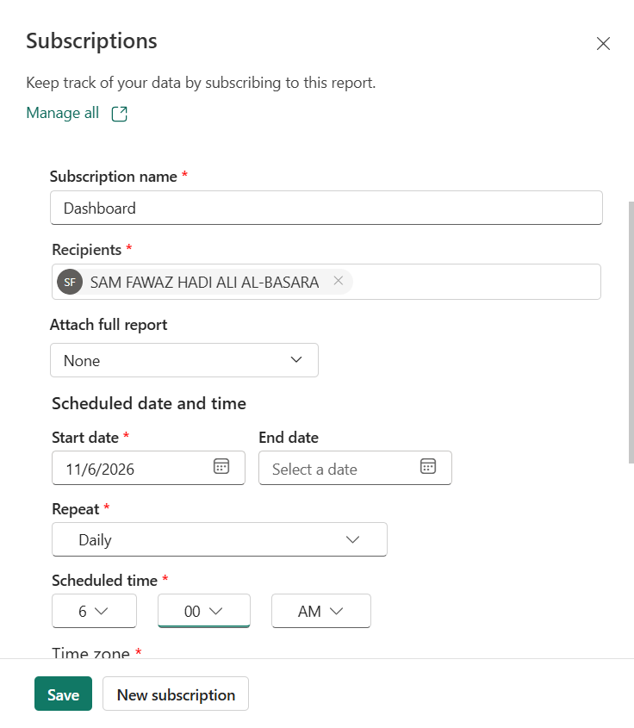
Figure 1: Subscription for the Dashboard page, daily at 6:00 AM.
Step 7: Selected the Executive Dashboard page and created a second subscription: Repeat Daily, 6:00 AM, time zone (UTC+05:30) Chennai, Kolkata, Mumbai, New Delhi, start date 11/6/2026, end date 11/9/2026. Power BI confirmed: "Emails will be sent daily at 06:00 AM".
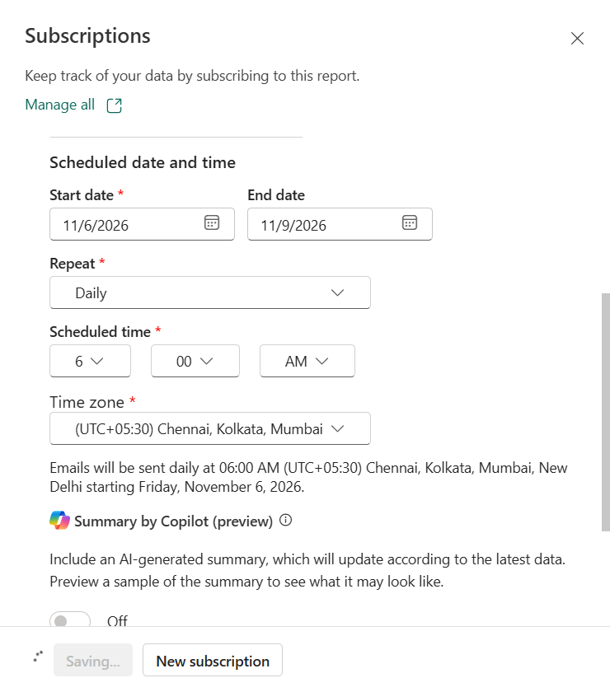
Figure 2: Subscription for the Executive Dashboard page, daily at 6:00 AM (UTC+05:30).
Step 8: To verify delivery on the same day, created a test subscription for the Business Scorecard page at 11:15 PM.
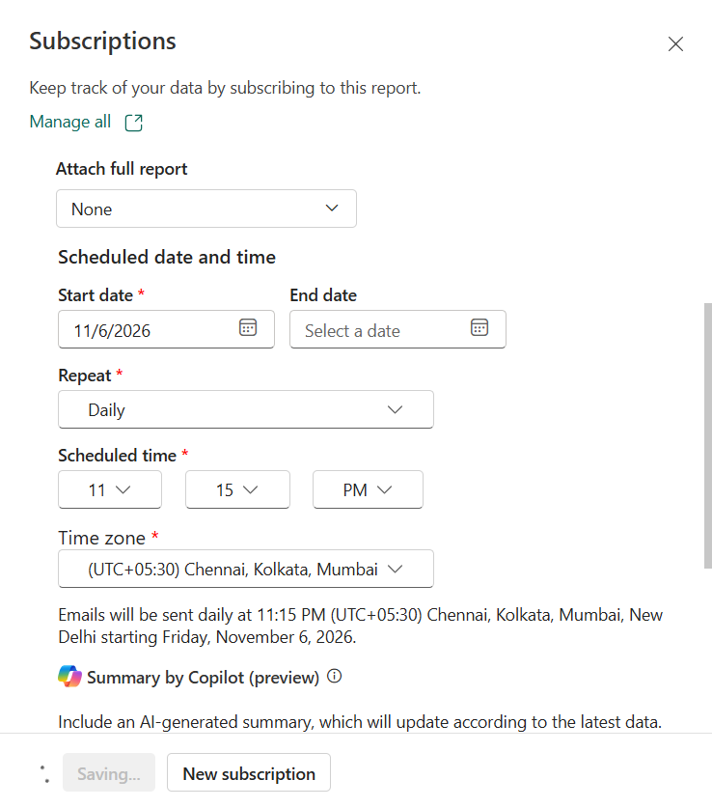
Figure 3: Test subscription for the Business Scorecard page at 11:15 PM.
Step 9: Checked the university Outlook inbox. The email "Subscription for BI Expe-8 (Business Scorecard)" arrived at 11:15 PM with a snapshot of the page (Sales 9.60M, Profit 1.10M, Orders 26K, all three KPIs Achieved) and an Open report in Power BI button.
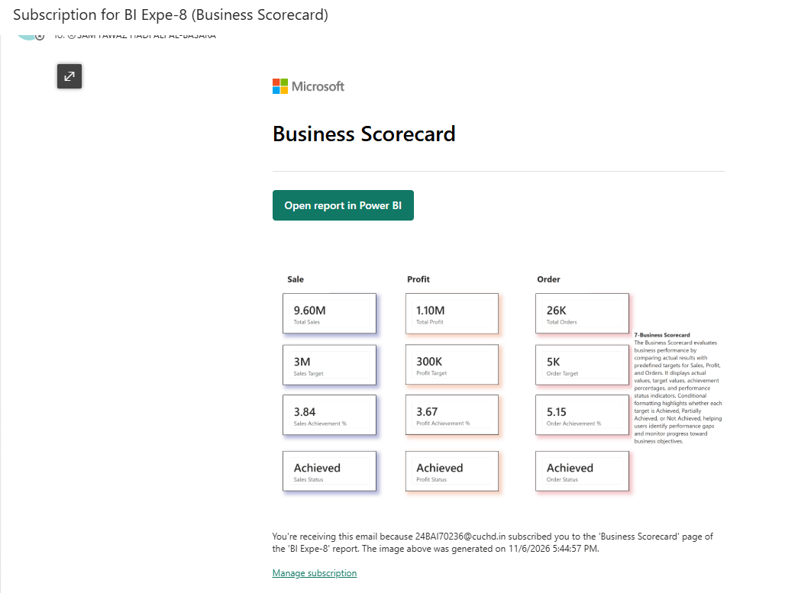
Figure 4: Subscription email received in Outlook with the Business Scorecard snapshot.
Deliverable 1, Scheduled Reporting Plan (implemented):
Subscription | Page | Repeat | Time | Time Zone | Status
Dashboard | Dashboard | Daily | 6:00 AM | UTC+05:30 | Active from 11/6/2026
Executive Dashboard | Executive Dashboard | Daily | 6:00 AM | UTC+05:30 | 11/6/2026 to 11/9/2026
Business Scorecard (test) | Business Scorecard | Daily | 11:15 PM | UTC+05:30 | Email received

Part B: Automated Distribution Design
Step 10: Designed the distribution of each report to the user groups that act on it. PDF attachments are set with Attach full report > PDF in a subscription; workspace access is given through Manage access, and single users are added with Share.
Deliverable 2, Report Distribution Matrix:
User Group | Report(s) | Frequency | Delivery Method | Access
Sales team | Daily Sales Report (Dashboard) | Daily, 6:00 AM | Email subscription (snapshot + link) | Viewer
Regional managers | Weekly Profit Report (Comparative Analysis) | Weekly, Monday 6:00 AM | Email + PDF attachment | Viewer
Finance team | Weekly Profit Report, Business Scorecard | Weekly / Monthly | Shared Workspace + Email | Viewer
Executives (CEO, Directors) | Executive Dashboard + Business Scorecard | Monthly, 1st at 6:00 AM | Power BI Service + PDF by email | Viewer
Operations / Quality | Returns Change % KPI | When alert fires | Alert email + Power BI Service | Viewer
BI team (owner) | All pages and semantic model | Continuous | Power BI Service workspace | Admin

Part C: KPI Alert Configuration
Step 11: On the Executive Dashboard page in Power BI Service, opened More options (...) on a KPI visual and selected Add alert (also available from Alerts and monitoring in the ribbon). For each KPI the condition, threshold, and email recipients were set.
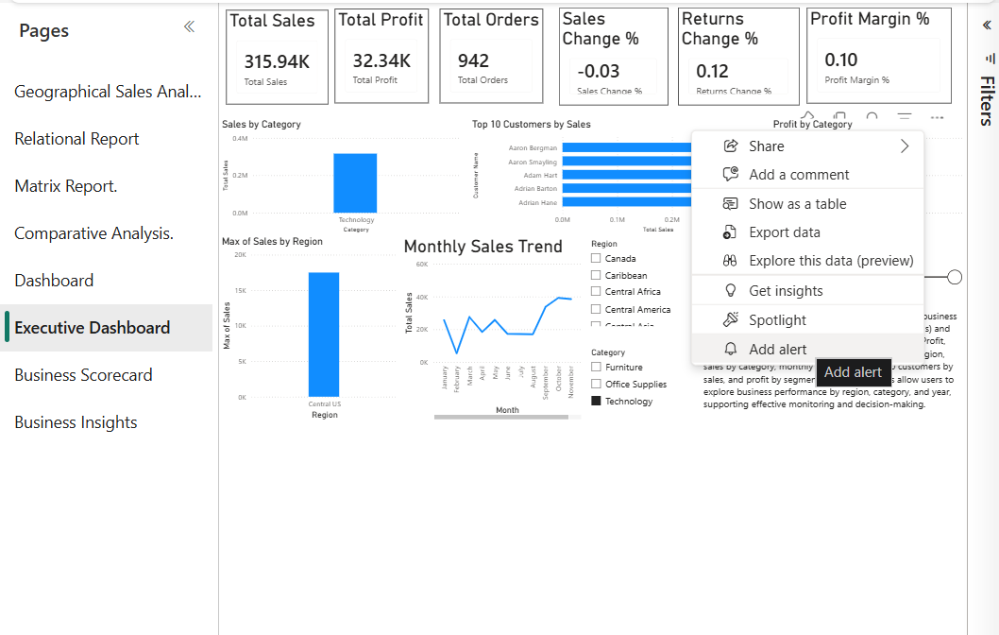
Figure 5: Executive Dashboard with the Sales Change % and Returns Change % cards, and the Add alert option on a visual.
Step 12: Recorded the current value of each KPI for 2017 (all regions) to check which alerts would trigger.
Deliverable 3, KPI Alert Configuration Sheet:
KPI | Condition | Threshold | Value (2017) | Status | Recipients | Action
Profit Margin % | Below | 10% | 11.5% | Normal | Finance, Head of Sales | Review discounts, pricing and costs
Sales Change % (YoY) | Below | -15% | +25.8% | Normal | Head of Sales, Marketing | Investigate demand, plan promotions
Returns Change % (YoY) | Above | +20% | +21.3% (539 to 654) | Alert | Operations, Quality team | Audit returned products and shipping
Profit Margin %, Southern US | Below | 10% | 5.8% | Alert | Southern US manager, Finance | Regional profitability review

Observation: with the Category slicer set to Technology (Figure 5), Profit Margin reads 0.10, exactly on the 10% threshold, Sales Change reads -0.03, and Returns Change reads 0.12. Alerts are evaluated when the data changes; because this lab uses fixed data, the alert rules are configured and will fire on the next data refresh.
Part D: Monitoring Scenario Analysis
Step 13: Filtered the Executive Dashboard to Region = Southern US to monitor the regional branch with the steepest fall in profitability.
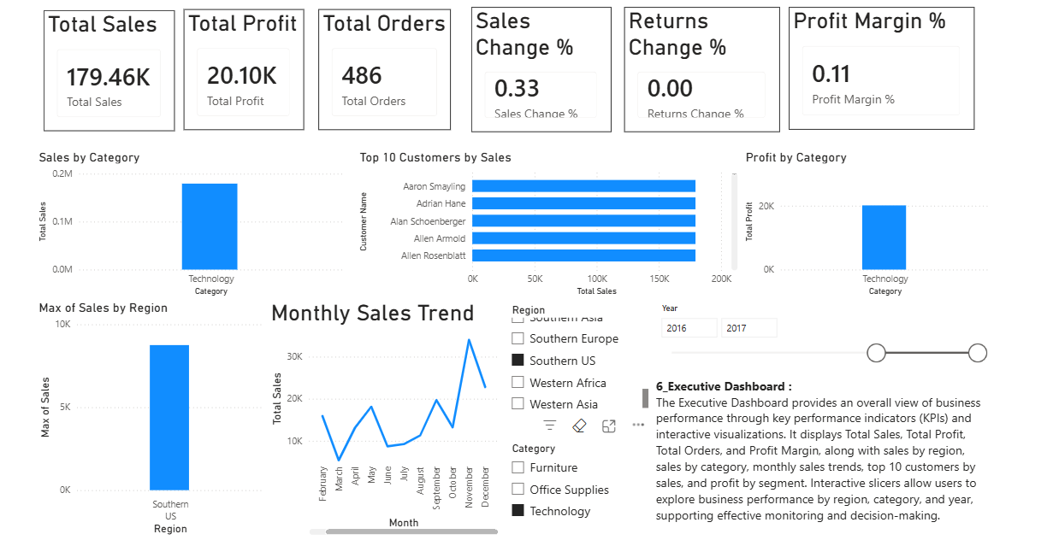
Figure 6: Deliverable 4: Executive Dashboard filtered to Southern US (Technology, 2016 to 2017).
Step 14: Compared the Southern US profit margin across years, quarters, and categories using the Matrix Report and the Executive Dashboard.
Measure | 2016 | 2017 | Change
Profit Margin, Southern US | 18.4% | 5.8% | -12.6 points
Furniture margin | 10.1% | -2.7% | -12.8 points
Technology margin | 24.6% | 7.0% | -17.6 points
Office Supplies margin | 18.3% | 12.9% | -5.4 points

2017 Quarter | Q1 | Q2 | Q3 | Q4
Profit Margin, Southern US | 19.1% | 18.8% | 11.8% | -6.6%

Step 15: Identified the alert triggers, recipients, and corrective actions, and prepared the Monitoring and Recommendation Report below.

MONITORING AND RECOMMENDATION REPORT (DELIVERABLE 5)
1. Situation
The Southern US branch shows declining profitability. Its profit margin fell from 18.4% in 2016 to 5.8% in 2017, while its sales grew by about 33%. In Q4 2017 the margin turned negative (-6.6%).
2. Alert Triggers
Trigger | Threshold | Actual | Result
Southern US Profit Margin % | Below 10% | 5.8% | Alert fires
Returns Change % (company) | Above +20% | +21.3% | Alert fires
Sales Change % (Southern US) | Below -15% | +33% | No alert

3. Root Cause
- Products: Machines (-3,908 profit) and Tables (-3,044 profit) were the main loss-making sub-categories in 2017.
- States: North Carolina (-5,285 profit) and Tennessee (-3,559 profit) account for most of the losses.
- Pattern: sales rose sharply in Q4 2017 while profit became negative, which points to heavy discounting to drive volume.
4. Recipients
Recipient | Role | Reason
Flannery Newton | Southern US Regional Manager (People table) | Owns the corrective plan
Finance team | Margin and cost control | Discount and pricing review
Head of Sales | Sales approval | Approves discount limits
Operations / Quality team | Returns handling | Returns alert (+21.3%)

5. Corrective Actions
- Cap discounts on Machines and Tables and require approval for discounts above 20%.
- Review pricing and customer mix in North Carolina and Tennessee.
- Stop or reprice loss-making Furniture lines in the region.
- Audit returned orders for product quality and shipping damage.
- Move Southern US to weekly profit monitoring until the margin is back above 10%.
6. Recommendations for BI Operations
- Connect the report to a live source (OneDrive or a database) and schedule a daily refresh at 5:00 AM, so the 6:00 AM subscriptions and alerts always use current data.
- Use Power Automate to forward alerts to regional managers and escalate if an alert repeats for two periods.
- Apply row-level security so each regional manager sees only their own region.
- Format all KPI cards as percentages and add a 3-month moving average margin to reduce false alerts.
7. RESULT
Report scheduling, automation, and alert strategies were successfully designed. Automated reporting plans and monitoring mechanisms were developed to support business operations.
Email subscriptions were created in Power BI Service for the Dashboard and Executive Dashboard pages at 6:00 AM (UTC+05:30), and delivery was verified with a test subscription whose email was received in Outlook. A Report Distribution Matrix and a KPI Alert Configuration Sheet were prepared, and the monitoring scenario identified Southern US as a declining branch (margin 18.4% to 5.8%) with corrective actions and BI operations recommendations.
8. LEARNING OUTCOMES
- Apply report scheduling concepts in BI systems.
- Design automated report distribution strategies.
- Analyze KPI monitoring requirements.
- Evaluate alert mechanisms for business decision support.
- Develop recommendations for BI operations.

